Q1) Using configuration management tool Ansible create multiple users and confirm on your manage host.

Weekly Assessment -2

**Solution**

Launched three instance that will server three different purpose

First instance will work as a configuration management tool to configure for the rest two hosts ans-one and ans-two .

In Ansible-server I have choses redhat distribution since it is manged by redhat

so works perfectly with redhatpython is required for ansible. In ansible we got python inbuilt (kernal >=3 all have inbuilt python installed).

Command to install ansible that I used is

yum install ansible-core* -y

Then modified the default configuration file for ansible

Added our two available hosts into hosts in the ansible directory

Since Ansible is an agentless tool. To communicate with mentioned hosts ssh is required so pasted the ssh public key of ansible to the available hosts into authorized_keys

And as we can see below we are able to access the ans-one with ansible server so everything is good to go

This will lists the available hosts

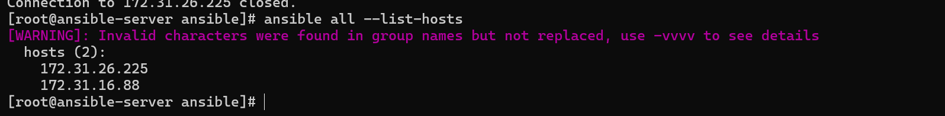

Added this into palybook name user.yaml

This will create users Vikash, Soni and Rahul into both the hosts because I have mentioned hosts as all

Now I have executed this playbook and everything is ok as showed by the yellow color.

Command used is

ansible-playbook user.yaml –syntax-check => to validate the syntax

ansible-playbook user.yaml => to execute this

Verifying users into ans-one

Similarly into ans-two

Q2) We have an EC2 instance in N. Virginia Region where a web server is running. create custom image of this server and launch new server in Ohio region using of this image

**Solution**

Launched an instance and named it dev-server into N.virginia region

I am installing it with the help of script file

Because it have several advantages –

* reduces typo error
* Can be reused
* And time efficient

With this help of this script I am installing httpd and starting it and putting some content into index.html

Executed by assigning a permission to execute

Now can see httpd is active and running

Here we can see our web-page



Now before creating an image out of this I will stop it since it is not recommended to make an image of a running instance because data come from disk to ram and then to cpu so there might be possibility that some data will not come.

Created an AMI(Amazon machine image)

And copied this image into ohio region

Now my image is reflecting into ohio region

So launched an instance with this image

Assigned hostname to it and can see with the help of rpmquery that httpd is already available and configured and status is also running

So I will directly move to running my web

And yes it is also running as can see into this screenshot

************************************The End **************************************